970805401389 87752669365

ӘБІЛЖАН Гүлбану Кайратқызы,
М.Горький атындағы жалпы білім беретін мектебінің ағылшын тілі пәні мұғалімі.
Түркістан облысы, Шардара ауданы

FAST MACHINES
Learning objectives(s) that this lesson is contributing to: | 4.2.3.1 contribute a growing range of suitable words, phrases, and sentences including giving opinions during short pair, group and whole class exchanges  4.4.3.1. recognise, identify and sound with support a growing range of language at text level
Lessonobjectives: | All learners will be able to: Recognize types of machines and name them
Valuelinks: | Respect each other.
Plan:
Part of the lesson/Time | Teacher’sactivity | Student’sactivity | Assessment | Resources
Beginning of the lesson  7 min. | Organization moment.  The lesson greeting.  Checking hometask  Revision of previous lessons materials with the help of the teacher.  Teacher asks pupils watch the video and guess todays theme. Then teacher asks different questions connected with the theme and tries to help pupils to give the correct answer.  «Brainstorming» method  Teacher asks leading questions to clarify the theme to the pupils who needs Teachers support.  Pupils give their possible answers. After that Teacher introduces the aim and theme of the lesson. | Pupils check the hometask  Pupils look at the pictures and tries to guess the theme  Questions:  - What did you see in the board?  - What about these pictures?  - What is our topic today? | Oral assessment  Descriptor:  -answers the questions  Encourage pupils who answer the questions | Active board  PPT  pictures
Middle of the lesson  7min. | Teacher introduce pupils with new words  Vacuum cleaner – [ˈvækjʊəm ˈkliːnə ] – шаңсорғыш  Microwave – [ˈmaɪkrə(ʊ)weɪv] – микротолқынды пеш  Hairdryer – [ˈheədraɪə ] – шаш кептіргіш  Digital thermometer – [ˈdɪdʒɪt(ə)l θəˈmɒmɪtə] – сандық термометр  Calculator – [ˈkælkjʊleɪtə ] – есептегіш құрал  Dishwasher – [ˈdɪʃwɒʃə] – ыдыс жуғыш машина  Fridge– [frɪdʒ ] – тоңазытқыш  Blender – [bruːm] –блендер  “Clothes peg” method  Drill the vocabulary. Teacher hides one of the pictures or put the pictures disorder. They should memorize the order of the pictures and guess them. | Pupils write the words correctly and work with translation. | Descriptor:  -writes new words correctly | Active board  PPT
5 min | New grammar  Order of adjectives  WATCH THE VIDEO | Pupils point the correct musical instruments and say | Descriptor:  A learner  -points musical instruments  Formative assessment | Active board  Students Book
5 min. | Ask pupils to work in pairs and complete the dialogue. Teacher gives a colourful fan with dialogues to the pupils  Board game  Speaking  - Pupilsbook. P.121 ex 18 | Pupils work in pairs and complete the dialogue | Descriptor  A learner  -works in pairs  -completes the dialogue  Formative assessment | Active board  PPT  worksheet
5 min | Teacher ask pupils to work individually and match the pictures.  Pupils book p.121. ex 19  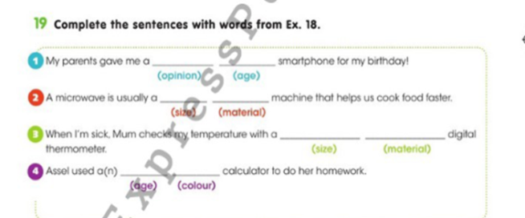 | Pupils unscramble the words | Descriptor  A learner  -works individually  - matches the words with sentences  Formative assessment | Active board  PPT  https://wordwall.net/resource/22320599
3 min | T: ask pupils watch the video and do the actions. Now it is relaxing time | Pupil watch the video and do actions | Oral assessment | Video
5 min | Teacher divides the pupils into 3 groups by cards.  1st group –  2nd group –  3rd – group -  Teacher ask pupils to work in groups and make poster  GROUP WORK  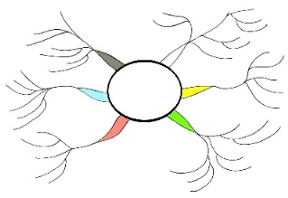 | Pupils divide into 3 groups by cards  Pupils work in groups and makes a poster | Descriptor:  -works in a group  - makes a poster  - performs to whole class | Active board  PPT  Poster
5 min | “Magic box” method  Teacher explain the rules of this game. Teacher gives a box to the pupil and the pupil quickly give the box until the music stops, whoever has the box takes one word out of it and speaks English translation. | Pupils play a game | Descriptor:  - plays a game  - translates the word | Cards  Box
End of the lesson.  Reflection  3 min. | Purity feedback used as a reflection. Teacher asks pupils to write a feedback on the lesson  Assessment  Giving hometask | Pupils write in a sticker and give feedback | Pupils evaluate each other and encourage classmate with phrases like:  Well done! Brilliant! Good job! I like it! | Active board  Students Book  chart

